DoubleTree by Hilton Harrogate Majestic Hotel & Spa
Ripon Road, Harrogate, North Yorkshire HG1 2HU
Tel: 01423 700 300 Fax: 01423 502 283

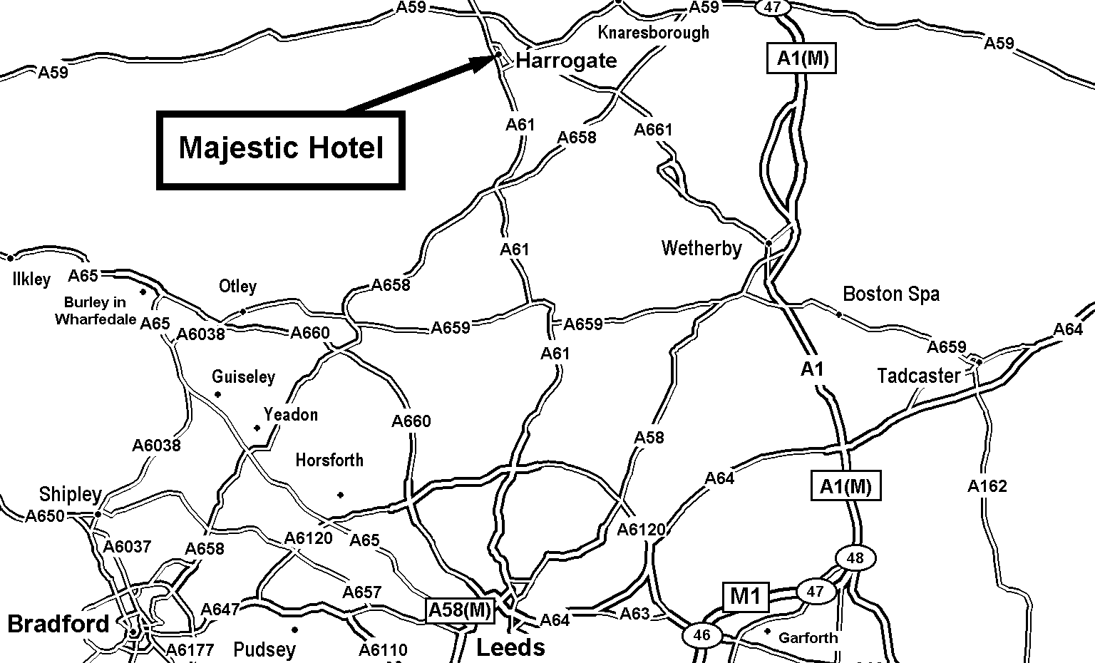
From M1 - Follow M1 north to A1 (M), take the Harrogate exit and follow A59 to Harrogate.
From M62 - leave at junction 29 and join the M1 – Northbound, then follow as above.
From A1 (heading south) - take the York / Harrogate exit and follow A59 to Harrogate
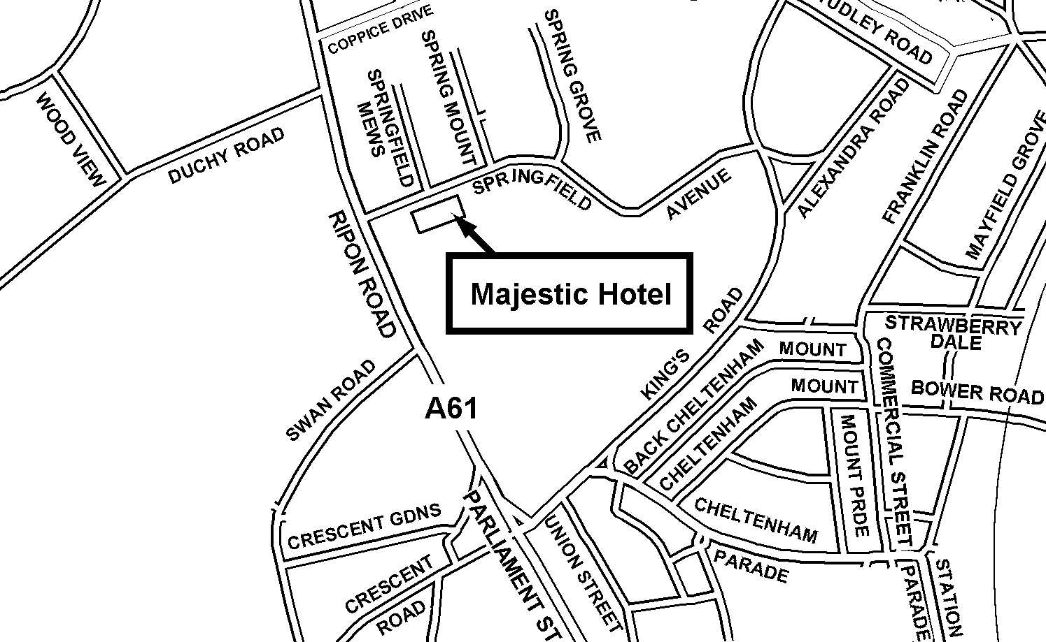
Reproduced from the Infomap, PJsoft Ordnance Survey map by permission of Ordnance Survey on behalf of the controller of Her Majesty’s Stationery Office, © Crown Copyright MC 100029112

DIRECTIONS FROM THE NORTH – LEEDS

Take M62 Leeds then take M621 which will lead onto A61, follow signs
for Harrogate, once in Harrogate follow the signs for town centre keeping
on the A61, after the second roundabout you will enter a one way system keep
on the inner left hand lane, go straight down Parliament Street, past “Bettys”
on your left hand side, go through the lights at the bottom of the hill the St.
George is on your left, turn right onto Springfield Avenue, car park entrance
is on your right.

DIRECTIONS FROM THE SOUTH – WETHERBY

Follow the signs for the A661 to Harrogate, you will see the Yorkshire Show
Ground and Sainsburys on your left. Continue on until the next roundabout
turn left and follow the town centre signs to the next roundabout, turn right
you are now on the “one way system” stay in the inner left hand lane, you
will see Bettys on your left, continue down through the traffic lights at the
bottom of the hill you will see the St. George on the left turn first right on to
Springfield Avenue the car park is on the right hand side.

DIRECTIONS FROM YORK

Follow the signs for the A59 through Knaresborough and Starbeck, turn
right at the Empress Roundabout, you will see the fire station and Jewsons
wood yard on your left. At the next traffic lights turn left onto Kings Road
continue on until the next traffic lights turn right onto Springfield Avenue
the car park entrance is at the top of the road.

DIRECTIONS FROM RIPON NORTH EAST

Follow the signs for the A61 to Harrogate, go straight across the roundabout
follow the town centre signs turn left onto Springfield Avenue, the car park entrance is on your right.

